Benha University
Faculty of Computer & Information Sciences

Artificial Intelligence
Third Year Second Semester

Time: 1 hour

Answer all questions
  - For propositional expressions P, Q and R prove that:
- (P Q) (P → Q).
- (P → Q) (Q → P).
- (P Q) (P → Q).
- P (Q ^ R) (P Q) ^ (P R)

- Represent the following English sentences in predicate calculus:
- If it doesn’t rain on Friday we will go to the park.
- Emma is a Doberman pinscher and a good dog
- All basketball players are tall.
- Nobody likes taxes.

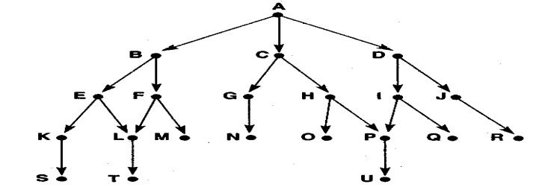
Write and trace the algorithms of Depth-first and Breadth-First search by using this graph.

Good Luck

